1. Agenda:
   1. Let’s create Beans and add to Spring Context.
   2. This way IOC container can create them and maintain them in our app.
2. Bean:
   1. A plain POJO Java Class whose object is maintained by Spring IoC container.
3. How an IoC container knows whether it must maintain a java class or not?
   1. If we add configuration inside our project, the class will be converted into bean and will be maintained by IoC container.
4. Diagram

   Description automatically generated with low confidence
5. Graphical user interface, text, application

   Description automatically generated
6. @Configuration, @Bean
7. 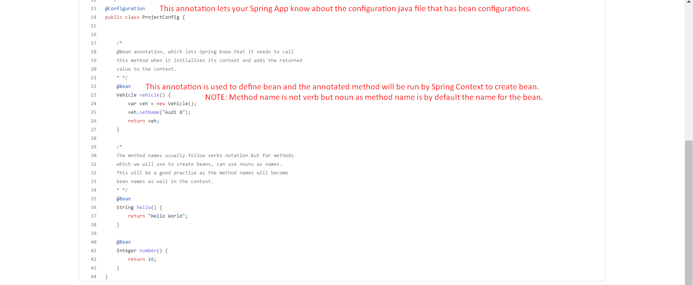
8. AnnotationConfigApplicationContext.java  
   Graphical user interface, text, application, email

   Description automatically generated
   1. Implementation for ApplicationContext.
   2. As using annotation style of configuration, so using this context.
   3. Will create Spring IoC Container.
   4. new AnnotationConfigApplicationContext(ProjectConfig.class)